Materials:

2- 10 foot 2 X 6 pieces of pine

2- Large cedar shims (to wedge skis that are on edge for sharpening

8- 3” screws

1 – Sheet of rubber/foam tool box liner material for anti-slip pads

Staples to affix the anti-slip pads

Anti-slip Pads made up of rubber/foam tool box lining sheet cut to size and stapled to wood

* 4 on top of each cross bar
* 2 at each bottom end of long frame member to not slip on bench top

2 notches- 2½” deep and 1½” wide

2 notches- ½” deep and 1 3/4” wide

½” wide notch cut 1 ½” deep, centered

2 ½”

12”

12”

78”

25”

20”

10”

15”

18”

13”

Make 2 of each part

*All notches are 1 ½” X 1 ½”*

Skis held on a knife edge for side edge sharpening.

* *Note: I use old ski straps or broccoli rubber bands to hold back brakes away from the edges*

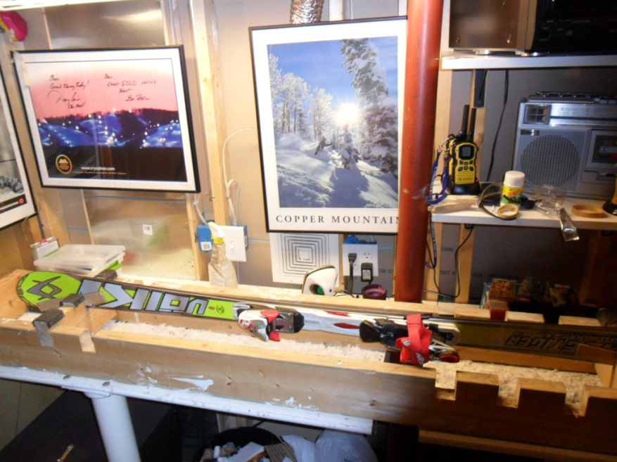

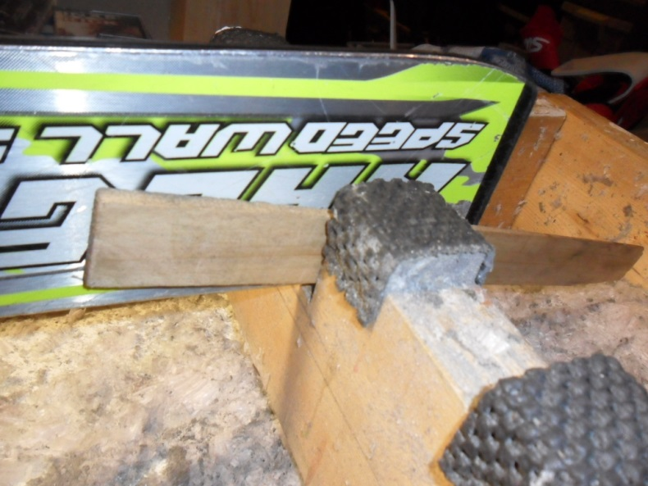

Skis held on a knife edge for side edge sharpening.

*Close up view of how I use the large shim to edge the ski in place on both ends.*

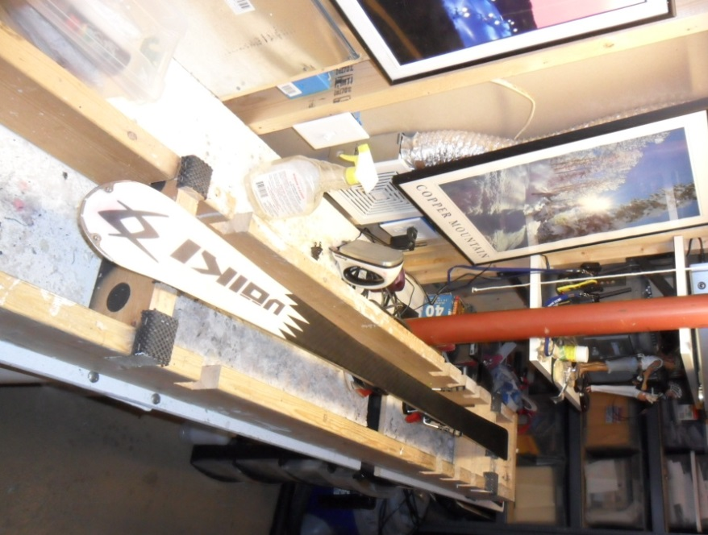

Skis set on anti-skid top pads for base edge sharpening or waxing.

* *Note: the notches cut on the top of the cross piece gives rom for the file holder to pass over the ski without lifting off the edge*